Experience and Perception on Performance of Local Governance
In the Municipality of Fier

September 2014
bACKGROUND 7
1. Executive Summary 7
1.1 Quality of life in the city of fier 7
1.2 Evaluation of public services in the city of fier 8
1.3 Performance and transparency of public administration in the city of fier 9
1.4 Perception and experience with corruption in the city of fier 9
1.5 Opinions on local economy in the city of fier 10
1.6 Quality of life in the city of lushnja 11
1.7 Evaluation of public services in the city of lushnja 12
1.8 Performance and transparency of public administration in the city of lushnja 12
1.9 Perception and experience with corruption in the city of lushnja 13
1.10 Opinions on local economy in the city of lushnja 14
2. Methodology, Overall Approach and Sampling Method 15
3. presentation of findings 19

MUNICIPALITY OF FIER
4. Quality of life in the city of fier 21
4.1 General quality of life 21
4.2 Most serious problems that the city is facing 22
5. Evaluation of public services in the city of fier 23
5.1 Responsibility on problem solving 23
5.2 Satisfaction with public services 24
5.3 Public services level of improvement 24
5.4 Public service priorities 25
6. performance and transparency of public administration in the city of fier 26
6.1 Transparency of Central and Local government 26
6.2 Information on the activities and services of the local government 26
6.3 Evaluation of administration operations of the local government 27
6.4 Main sources of information used to get informed on city matters/activities of municipality 27
6.5 Main 3 mediums of information 28
6.6 Accessibility and availability of information by the local government 29
7. Perceptions and experiences with corruption in the city of fier 30
7.1 Citizen contacts with municipal structures 30
7.2 Overall satisfaction with services received 31
7.3 Demand of bribe 31
7.4 Perception on level of corruption in sectors/institutions of municipality 32
7.5 Perception on level and nature of corruption in sectors/institutions of municipality 33
7.6 Perception of corruption in everyday scenarios 34
8. Opinions on local economy in the city of fier 36
8.1 Information on taxes and local fees 36
8.2 Economic growth and standard of living 37
8.3 Potential economic sectors 38
8.4 Involvment of local government in stimulating and managing economic growth 39
8.5 Civil society 40

MUNICIPALITY OF LUSHNJA
9. Quality of life in the city of lushnja 42
9.1 General quality of life 42
9.2 Most serious problems that the city is facing 43
10. Evaluation of public services in the city of lushnja 44
10.1 Responsibility on problem solving 44
10.2 Satisfaction with public services 45
10.3 Public services level of improvement 45
10.4 Public service priorities 46

11. performance and transparency of public administration in the city of lushnja 47
11.1 Transparency of Central and Local government 47
11.2 Information on the activities and services of the local government 47
11.3 Evaluation of administration operations of the local government 48
11.4 Main sources of information used to get informed on city matters/activities of municipality 48
11.5 Main 3 mediums of information 49
11.6 Availability and accessibility of information by the local government 50
12. Perceptions and experiences with corruption in the city of lushnja 51
12.1 Citizen contacts with municipality or other related office/sector 51
12.2 Overall satisfaction with services received 52
12.3 Demand of bribe 52
12.4 Perception on level of corruption in sectors/institutions of municipality 53
12.5 Perception on level and nature of corruption in sectors/institutions of municipality 54
12.6 Perception of corruption in everyday scenarios 55
13. Opinions on local economy in the city of lushnja 56
13.1 Information on taxes and local fees 56
13.2 Economic growth and standard of living 57
13.3 Potential economic sectors 58
13.4 Involvment of local government in stimulating and managing economic growth 59
13.5 Civil society 60

Recommendations 61

DISCLAIMER
This study has been prepared by the Institute for Development Research & Alternatives (IDRA) with the technical and financial support of the Organization for Security and Co-operation in Europe (OSCE) in Albania in the framework of “Assessing corruption levels in Fier and Lushnja Municipalities and building capacity of local government and civil society to more effectively interact and cooperate in tackling corruption” Project. This project is funded by the Italian Ministry of Foreign Affairs and International Cooperation.

The opinions and views expressed in this study are of the authors and do not necessarily represent those of OSCE or Italian Ministry of Foreign Affairs and International Cooperation.

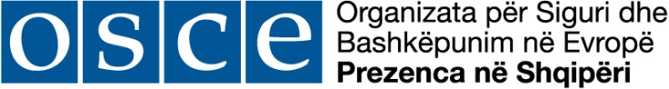
Ministero degli Affari Esteri
e della Cooperazione Internazionale

OSCE

The OSCE has a comprehensive approach to security that encompasses politico-military, economic and environmental, and human aspects. It therefore addresses a wide range of security-related concerns, including arms control, confidence- and security-building measures, human rights, national minorities, democratization, policing strategies, counter-terrorism and economic and environmental activities. All 57 participating States enjoy equal status, and decisions are taken by consensus on a politically, but not legally binding basis.

The OSCE Presence in Albania project “Assessing corruption levels in Fier and Lushnja Municipalities and building capacity of local government and civil society to more effectively interact and cooperate in tackling corruption” aims to better understand the weaknesses of local administrations in these two cities in tackling corruption and corruption perceptions of citizens and improve the interaction between civil society and local government for an accountable and transparent local government.

BACKGROUND
The “Urban Corruption Perception Survey” was implemented in the framework of the project “Assessing corruption levels in Fier and Lushnja municipalities and building capacity of local government and civil society to more effectively interact and co-operate in tackling corruption”. The focus of this project is to strengtthen the interaction between local government and civil society by encouraging the dialogue and providing means of cooperation in assuring transparency and accountability in local governance and reducing corruption potentials. The Project was implemented in cooperation with the Fier and Lushnja municipalities and it aimed to achieve two results:
- The weaknesses of Fier and Lushnja Municipalities in tackling corruption and the corruption perception of citizens are better understood;
- The interaction between local government and civil society for an accountable and transparent local government is improved.

The Urban corruption Perception Survey in Fier and Lushnja municipalities was undertaken in order to better understand the public perception on corruption, services delivered, transparency and experiences of corruption in interacting with the local government.
EXECUTIVE SUMMARY

1.1 Quality of Life in the City of Fier

- Fieri residents are split in half when asked about the Quality of Life in general in their city, with half of them claiming the quality of life in Fier is “Good” and another half claiming it is actually “Bad”.
Only 1 in 4 respondents thinks that the Quality of Life in Fieri has “Somewhat Improved” during the last 3 years, meanwhile almost half of respondents claim that there is no change in this direction.

- “Unemployment” is the most serious problem with which the city of Fieri is being faced with. About 49% of the respondents have mentioned it is the first most serious problem. Economy, in general is the main concern of Fieri Citizens when also counting “Economic Problems” mentioned by another 19% of respondents.

- When counting all problems with which the city of Fieri is being faced with, “Weak Infrastructure” comes up as the second most mention problem. “Environmental Problems” are also significantly present on Fieri respondents radar of problems their city if being faced with.

- Interestingly enough, Corruption is not very high on the people’s radar when talking about the most serious problems the city is facing. It is mentioned as a serious problem by only about 12% of the respondents. However, it’s worth noting that the problems mentioned by the respondents are of very basic nature (Employment, Economy, Infrastructure, Environment etc.), and these are naturally higher in the amplitude of seriousness in the eyes of respondents because they are related to basic day to day needs of citizens. This does not neccessarily mean that Corruption is not seen as a problem overall.

1.2 Evaluation of Public Services in the city of Fier

- In the area of competencies of government levels on different public services (which level is primarily responsible, Central or Local Government), there is still confusion among respondents on several services. The most notable area is the “Employment Office”. Surprisingly, 55% of respondents in Fieri, hold Local Government as primarily responsible for this service. Only 44% correctly state that it is the Central Government responsibility. Other areas of confusion include Pre-school Education, Construction of Educational Facilities and Primary Health Care. On the other hand respondents are clear on basic Public Services (Cleaning, Street Lightning, Maintenance of Roads and Sewerage) that are of Local Government responsibility.
- Fieri citizens are more satisfied with the Drinking Water Supply, City Cleaning Service, Maintenance of Pre-University Buildings and to a certain extent Sewage Service, with over half or more citizens claiming to be generally satisfied by these services.
On the other hand they are not satisfied with Maintenance of Roads (69% Unsatisfied) and Street Lightning (56% Unsatisfied). These two areas should be the focus of Municipal intervention.
- Respondents were specifically asked about the priorities where Fieri Municipality should focus given the lack of funds to support all areas of public service. The highest priorities where the city should concentrate its efforts, according to respondents are the Condition of City Roads (71% High Priority), followed by the Availability of Green Areas / Parks, Cleanliness of City, Drainage Systems, and Street Lightning.
- Condition of City Roads, (whether coming up as weak infrastructure while exploring problematic areas of the city or as general dissatisfaction of the public with the maintenance done by the Local Government to city roads) highly figures on Fieri citizens city-problems they have to deal with every day and thus requiring the immediate attention of the Local Government.
- 1.3 Performance and transparency of public administration in the city of Fier
- Fieri respondents think that the Local Government is in general not transparent. On a scale from 0-100, where 0= Not transparent at all and 100= Fully transparent, they have evaluated their Local Government with 26 points, way below the mid scale. When further asked, how well the Municipality keeps them informed, only about 29% have respond positively while over 65% figure with a negative point of view in this matter.
- “Behavior of municipal employees”, “Clear rules in writing” and to a certain extent “Convenient Working Hours” & “Timely Service” are among the better evaluated dimensions of Local Government performance. The situation is less so when judging “Performance in Responding to Citizens”, “Ability to Solve Problems” and “Creating a Feeling of Trust”.
Fieri citizens have a generaly positive attitude towards service-oriented instances of the Local Government while performance-oriented instances fall behind scoring lower on the evaluation scale.

- Local television stations are the main source of information about local news and municipal activities (mentioned by 79% of respondents). National television follows with only 23% of respondents mentioning it. Interestingly, the Municipal Website is mentioned only by 9% of the respondents as a main source of information. Even more so, Social Networks (while widely used) are also not considered as a main source of information for local news (only 8% mention them as such).

1.4 Performance and transparency of public administration in the city of Fier

- Overall, citizens of Fieri show high interaction with the Municipal structures. About half of the sample declare to have contacted, during the past 12 months, at least once with municipal structures (Municipal offices such as Information, Public Services, Urban Planning, Taxation, Procurement, Social Assistance, Water/Sewage, Local police, or Municipal Council).
- Respondents who interacted with different Municipal Structures were asked whether at any point during the interaction was implied that they had to bribe (in the form of money, gifts of favours), to get the service/solve their case. While the intensity of interaction changes from office to office (in some offices there is higher citizen interaction than in others), the most mentioned offices for implying that some kind of bribery had to be involved are the “Construction Inspectorate” and “Urban Planning Office”.
- There is a theory that usually Perception about corruption is higher than the reality. If we compare the opinions of those who have had Personal experiences with municipal structures and those who base their opinion on Indirect experiences, in almost all the institutions evaluated, the perception on corruption level, is higher among those that have had personal experience than among those with indirect experience.
- Respondents were also presented with different corruption scenarios and asked whether the persons involved were corrupted and should be punished or were in any way justified while engaging in the corruption related activities that were presented. Interestingly enough, there is a difference in judging the “Demand” side of a corrupt transaction compared to the “Supply”side. Respondents are more tolerant when judging the “Supply” side and a highly tolerant attitude is noticeable with up to 73% of respondents not mentioning “Punishment” in relation to at least one corrupt transaction presented.
- Respondents are more prompt in punishing the corrupted party in the classic clear cut scenarios of corruption (like the municipality employee accepting different amounts of bribes, or the politician misusing his influence) with up to 58% of respondents judging these behaviours as “Corrupted and in need of Punishment”, while they seem to justify or even not punish at all scenarios like the one involving the person that hired the employee (after the politician interfered) or the citizen that bribes so he doesn’t have to wait in line etc.
- Respondents were also asked about the most common nature of bribery in their opinion. Over 91% think that Money (Cash) is the most common form of bribery, while only 7% mention Personal Favours as another possible form of corruption.
1.5 Local Economy Opinions in the City of Fier
- Up to 76% of respondents from Fieri are aware of their obligations regarding taxes and other local fees. It also seems the respondents prefer to inquire directly at the Municipal Office/Public Institutions or by asking Friends for information of this nature. Yet again, the Municipality Web Page is used for information by only 3% of respondents.
- About half of Fieri respondents express their pessimism by stating that the economic growth of their city is declining, while about 37% think that the economy is not actually changing at all. Only 11% think that the economy is growing. The results are very similar when respondents are asked about their own standard of living situation.
- “Development of Agricultural Products/Agro-processing” along with “Heavy Industry” (the case of oil production and processing) are described as the strongest and most promising engines of economic growth. “Light Industry” also shows potential according to Fieri respondents.
- More than 2 in 3 respondents think that the Local Government is little or not at all Involved in stimulating and managing economic growth. While the current situation in this regard is not very positive, respondents show a higher level of optimism when asked about the future role of the Local Government in this regard. When the respondents were asked regarding the involvement of the Local Government in the next 5 years, up to 58% seem optimistic the Local Government will actually be involved in stimulating and managing future economic growth.
1.6 Quality of life in the city of Lushnja
- Lushnja residents are split in half when asked about the Quality of Life in general in their city, with half of them being positive towards the quality of life in their city and another half figuring negatively in this regard. Only 1 in 4 thinks that the Quality of Life in Lushnja has “Somewhat Improved” during the last 3 years. About 39% say that there is no change in this direction, while about 28% say that the quality of life has worsened during the past 3 years.
- “Unemployment” is the most serious problem with which the city of Lushnja is being faced with. About half the respondents have mentioned it as the first
- most mentioned problem the city if being faced with.
“Weak Infrastructure” also figures highly according to citizens of Lushnja when when asked about other serious problems the city of Lushnja is being faced with.
“Environmental Problems” are also mentioned by at least a third of Lushnja citizens as serious problem the city is being faced with.
- Interestingly enough, Corruption is barely present on the people’s radar when talking about the most serious problems the city is facing. It is mentioned as a serious problem only by about 4% of the respondents. However, it has to be mentioned that the problems mentioned by the respondents are of very basic nature (Employment, Economy, Infrastructure, Environment etc.), and these are naturally higher in the amplitude of seriousness in the eyes of respondents because they are related to basic day to day needs of citizens. It does not mean that Corruption is not seen as a problem overall.
1.7 Evaluation of Public Services in the city of Lushnja
- In the area of competencies of government levels on different public services (who is primarily responsible, Central or Local Government), there is still confusion among the respondents on several services. The most notable area is the “Employment Office” where up to 64% of Lushnja respondents hold the Local Government primarily responsible for this service.
Other areas of confusion include Primary Health Care, Pre School/University Educations, Construction of Educational Facilities and Electricity Supply.
Respondents are clear on basic public services (Cleaning, Street Lightning, Maintenance of Roads and Sewerage) that are in the responsibility of the Local Government.
- Citizens are generally not satisfied with Lushnja’s public services, since no evaluation actually passed the medium standard of satisfaction. Services like the Maintenance of Pre-University buildings or Daily Supply of Drinking Water Supply scored somewhat better than rest, while the situation seems more alarming with the Maintenance of Roads (73% Unsatisfied), Sewage Service (68% Unsatisfied) and Cleaning Service (55% Unsatisfied). These three areas should be a priority for Municipal intervention.
- Respondents were specifically asked about the priorities where Lushnja Municipality should focus given the lack of funds to support all areas of public service. The highest priorities where the city should concentrate its efforts according to respondents are the Condition of City Roads, Cleanliness of the City and Daily Water Supply.
Respondents were also asked to name one service that needs the immediate attention of the Municipality. In this case Daily Water Supply figures as the top problematic public service requiring the utmost immediate intervention by the Municipality.
1.8 Performance and Transparency of Public Administration in the city of Lushnja
- Lushnja respondents think that Local Government is in general not transparent. On a scale from 0-100, where 0=Not transparent at all and 100=Fully transparent, they have evaluated their Local Government with 27 points, way below the mid-scale. When further asked, how well the Municipality keeps them informed, only about 36% have responded positively, while over 60% figure negatively on this matter.
- Service-oriented instances like “Behavior of municipal employees”, “Clear rules in writing”, “Convenient working hours” and to a certain extent “Performance in general responding to citizens” are among the better evaluated dimensions of Local Government. The situation is less so when judging about performance-oriented instances like “Ability to solve problems / Give answers”, “Easy to contact the right person” and “Creating a feeling of trust”.
- Local television stations are the main source of information about local news and municipal activities according to over 2 out of three respondents. “National televisions” follow with only a third of respondents mentioning them. Interestingly, the “Municipality Website” is mentioned by only 8% of the respondents as a main source of information. Even more so, Social Networks (while widely used) are also not considered as a main source of information for local news (only 2% mention them as such).
1.9 Perception and Experience with Corruption in the city of Lushnja
- Overall, citizens of Lushnja show high interaction with Municipal structures. More than half of the sample declare to have contacted during the past 12 months at least once with municipal structures (Municipal offices such as Information, Public Services, Urban Planning, Taxation, Procurement, Social Assistance, Water- Sewage, Local Police etc. or Municipal Council).
- Respondents who interacted with different Municipal Structures were asked whether at any point during the interaction was implied that they had to bribe (in the form of money, gifts of personal favours), to get the service/solve their case. While the intensity of interaction changes from office to office (in some offices there is higher citizen interaction than in others), the most mentioned offices for implying that some kind of bribery had to be involved are the “Construction Inspectorate”, “Welfare Office” and “Municipal Police”.
- Once more the theory that usually perception about corruption is higher that the reality is applied. If we compare the opinion of those who have had personal experience with municipal structures and those who base their opinion on Indirect experiences, in most of the institutions evaluated, the perception on corruption level is higher among those that have had personal experience than among those with indirect experience.
- Respondents were also presented with different corruption scenarios and asked whether the persons involved were corrupted and should be punished or were in any way justified while engaging in the corruption related activities that were presented. Interestingly enough, there is a difference in judging the “Demand” side of a corrupt transaction compared to the “Supply“ side. Respondents are
- more tolerant when judging the “Supply” side and a significantly tolerant attitude is noticeable with up to 54% of respondents not necessarily mentioning “Punishment” in relation to at least one corrupt transaction presented.
- Respondents are more prompt in punishing the corrupted party in the classic clear cut scenarios of corruption (like the municipality employee accepting different amounts of bribes, or the politician misusing his influence) with up to 74% of respondents judging these behaviours as “Corrupted and in need of Punishment”, while they seem to justify scenarios like the one involving the person that hired the employee (after the politician interfered) or the citizen that bribes so he doesn’t have to wait in line etc. (about 46% judge this behaviour as “Corruptive and in need of Punishment”.)

- Respondents were also asked about the most common nature of bribery in their opinion. Over 98% think that Money (Cash) is the most common form of bribery.
1.10 Local Economy Opinions in the city of Lushnja
- Over 2 in 3 Lushnja respondents are aware of their obligations regarding taxes and other local fees. It also seems the respondents prefer to inquire directly at the Municipal Office for information of this nature. Media or Information Leaflets are also mentioned as alternative sources. Meanwhile the Municipality Web Page is used for information yet again by only 1% of respondents.
- Almost half of respondents state that the economic growth of their city is declining and about just as many claim that the economy is not actually changing at all, nor that their standard of living has had any changes over the last 12 months.
- “Development of Agricultural Products/Agro-processing” is described as the strongest and most promising engine of economic growth by up to 82% of Lushnja citizens. “Warehouses and Transport” also shows potential in this regard, according to 52% of respondents.
- Again almost half of respondents think that the Local Government is Little Involved in stimulating and managing economic growth while only 1 in 5 think that the Local Government is actually Involved. There is a slight tendency of optimism when asked again about the potential involvement of the Local Government in the next 5 years, where more than a third of respondents now think that the Local Government will actually be Involved while only 11% are still negative on this matter.

METHODOLOGY, OVERALL APPROACH AND SAMPLING METHOD
The purpose of “Urban Corruption Perception Survey in Fier and Lushnja Municipalities” is to understand the public perception on corruption, services delivered, transparency and experiences of corruption in interacting with local government.
In order to ensure accurate information from the carefully selected target group, the study went through a series of implementation phases.
The overall process of “Urban Corruption Perception Survey in Fier and Lushnja Municipalities, 2014” is presented more in details here below:

Phase 1 – Preparatory Phase
The Preparatory phase consisted of: a) Questionnaire finalization, b) Piloting, c) Sampling and d) Design & Programming of the data entry platform.

In close collaboration with the Programme Management Team, IDRA reviewed the research instrument by adding demographic questions as well as providing insights from its vast experience in conducting surveys of large scales.

Before the printing phase of the questionnaires, IDRA performed pilot interviews, (15 pilot interviews) to understand and assure the regular and logical flow of questions in the questionnaire as well as assess the timing needed for the correct completion of the instrument. The pilot interviews were conducted by our most experienced enumerators in order to capture every nuance of understanding for all questions. After gathering the results from the piloting phase, the final changes were made to the questionnaire and communicated to the Client for further potential changes, feedback and approval.
In addition this phase also served for the correct definition of the sample taking into account all the different relevant criteria as well as for the design and programming of the data entry platform.

Phase 2 – Fieldwork Conduction
After the instrument is finalized, IDRA conducted training sessions for the selected enumerators, covering all the delicate aspects of this survey as well as carefully explaining different interviewing techniques that might come handy while on the field.
The field work was organized by 2 fieldwork coordinators, assisted by 3 fieldwork assistants/supervisors. The supervisors’ main role is much connected with the quality control measures in the field, explained in the “Quality Control” section below. Such measures require site visits to check the work of enumerators as well as telephone checking for logistical control of the questionnaire.
For the fieldwork implementation process IDRA deployed 35 enumerators.
In order to increase fieldwork efficiency as well as have real time checking of the overall picture as well as in each single sampling unit, IDRA’s has created a management information system (IDRA MIS) that allows for proficient coordination and control over the field.

Phase 3 – Quality Control Phase
IDRA reassessed up to 10% of the sample interviewed. Respondents that took part in this phase were selected randomly from each PSU that has been selected during the Sampling phase, assuring a critical mass of controlled respondents at PSU level. IDRA prepared a “Quality Control” Module, containing at least 5 questions from the study final questionnaire to verify the work of the enumerators.

IDRA understands that it is of crucial importance to have accurate data, and this is why another verification process took place in addition to the in-field quality control. An extra 10% of the randomly selected questionnaires were checked logistically (reached the respondent) and also a follow-up content tendency control (4-5 questions were re-asked to the respondent) via telephone/mobile.

In order to preserve respondents’ confidentiality of data, IDRA uses the personal contact information provided by the respondents for the sole purpose of verification of the enumerators work. This information will not be disclosed to any third parties.

The Quality Control phase started somewhat simultaneously (with an eight days delay) with the fieldwork phase in order to raise efficiency and to make the most out of the time available for the conduction of “Corruption perception Survey, 2014”.

The quality control assignment was performed by supervisors who underwent a specific training on the procedures and steps taken while in field.
Phase 4 – Data Entry and Cleaning Phase
Data entry was conducted by our data entry operators, supervised by 2 data entry supervisors, using a total of 16 computers. All data entry was conducted at IDRA office using manual data entry. For data entry, CSPro version 4.0 is used with a highly structured data entry program, using system controlled approach that checks the entry of each variable.

Phase 5 – Data Processing, Analysis and Report Writing
IDRA employs SPSS, a specialized package for statistical analysis as its main tool for processing results and statistical analysis. Statistical analysis employed includes:
- Descriptive statistics: frequencies, percentiles, mean, 5% trimmed mean, standard error, mode, skewness, kurtosis.
- Non-parametric comparison of means between two independent samples.
- Factor analysis: principal components analysis.
- K-means cluster analysis
- Difference of proportions t-tests.
- Spearman Rho correlation.
- Chi-square independence test.
First, IDRA produced output statistical tables. Once these results were produced the process of interpreting and visualizing the data (producing charts and visual tables) started.
Analysis of findings was done by highly qualified experts. After implementing the final changes due to the clients’ feedback and suggestions, IDRA will submit the amended final report.

Methodology and Sample Design
Up to 1000 face-to-face interviews were carried out in ”the selected area of research” . The survey results are reported on Municipality basis (having two survey reports were prepared, one for each municipality). Each Municipality has N=500 (with a margin error of 4,3% for each municipality) respondents since results at municipality level were produced. However, in compliance OSCE’s directives, a third report was produced, solely based on the “Perception and Experience with Corruption” module, with aggregated results, representative of a larger area than the specific municipalities, considering this area as one entity.
Three selection methods will be employed to ensure an accurate sample within the designated cities:
- Selection of Sampling points;
- Selection of Households;
- Selection of Respondents.

STEP1 - Selection of the Sampling Points
In the sampling process, the first step undertaken was the selection of the areas, the sampling units. IDRA possesses the maps of the two municipalities. Based on these maps, a multi-level design for sampling was created:
First, each city was divided into geographical clusters. These clusters were exhausting and non-overlapping. The population density and the maps’ scales were taken in consideration during this division.
Second, based on these major clusters, primary sampling units (PSUs) was designed (units of geographical area within the clusters). Starting from the most upper-left cluster and walking down horizontally, a consecutive natural number will be assigned to each cluster.
Third, 50 random numbers within the range of the total number of clusters were generated using the random number generating formula (for each municipality). The PSUs labeled with the numbers generated was selected. In each PSU, the interviewers conducted 10 interviews. So we have 500 Interviews in each city.
STEP2 - Selection of Households
Random Route Sampling method was employed for the selection of households to participate in the survey. This method consists in respecting some requirements such as the starting point, rule of the right hand, every third door. All the steps were followed in a rigorous manner ensuring thus a representative sample reflecting the distribution of the population.
-Starting Point
In each randomly selected primary sampling unit (PSU), the interviewers were provided with a map and a starting address including:
a) an exact address;
b) a crossroad, and
c) a well-known building in that geographical area.
Taking the starting address as a reference point, interviewers were instructed to follow a re-defined route.
-Household Selection
After identifying the “starting/reference point”, the interviewer was instructed to turn his/her back to it and start walking on the right-hand side looking for dwelling units (single houses or apartment buildings). S/he was instructed to count the households passed and approached for interview every third household counted.
STEP3 - Selection of respondents
Once the household is selected the interviewer screens the birthdays of all permanent residents of the household aged 18 years and above. The permanent resident that celebrated his/her birthday closest to the day of the interview date was selected for the interview. Note that only this respondent will be eligible for the interview. If the respondent will refuse to participate in the survey, the household will be categorized as a refusal and the next selected household will be approached. If the respondent is not at home at that time, the interviewer will try to establish a contact at least three times categorizing that household as a refusal.

PRESENTATION OF FINDINGS  Survey findings are often presented on a 0-100 scale for better understanding and presentation.  The following is an example of a question included in the questionnaire:  “Can you tell me your opinion about the transparency of the Central and Local Governments, on the scale of 1 through 7, where 1 = Not at all Transparent and 7 = Completely Transparent.”  A conversion is required to facilitate accurate statistical analysis. It is achieved by subtracting 1 from each point on the 1-7 scale so that the questions are scored on a 0 - 6 scale. The scale is then divided by 6, so that it ranges from 0-1, and multiplied by 100 to obtain a 0-100 range.  In this scale, 0 means “Not at all Transparent” and 100 means “Completely Transparent”.  An illustrative graph is presented on the right in which the “Municipality” received a score of “26.” The score does NOT mean that 26% percent of the public reported that the municipality is not transparent; it represents the perception of how corrupt the institution is on a 0 – 100 scale. In other words, “Municipality” received an average score of 26 points on a 0 – 100 scale as perceived by the public.  Another scale example found in the report:  How easy was it for you to find the information you were interested in? Please rate on a scale from 1 through 5, where 1 means “Very Easy” and 5 means “Very Hard”.  In this scale, 0 means “Very Easy” and 100 means “Very Hard”. | 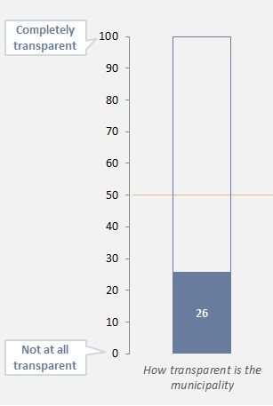

MUNICIPALITY OF FIER

QUALITY OF LIFE IN THE CITY OF FIER
4.1 General Quality of Life
Respondents opinions are split when asked about the quality of life in general in the city of Fier.
Almost half of the respondents think that the quality of life in the city of Fier is “Good”, while about just as many claim that the quality of life is “Bad”, with the only difference being 12% of respondents claiming that the quality of life is in fact “Very Bad” (Fig. 1).
Respondents were then asked whether the quality of life has changed at all over the last 3 years.
This time, up to 45% of Fieri sample claim that the quality of life “Has not changed” over the last 3 years, while the rest split again between 23% that claim that the quality of life has “Somewhat improved” and 28% that think it has “Somewhat worsened” (Fig. 2).
It is also worth noting that when different age groups are seen separatelly, Fieri youth (18 – 34 years old) tend to be more positive while stating their opinion over the general quality of life in their city, compared to older age groups (35 – 54 and 55+ years old).

4.2 Most serious problems that the city is facing  Over two thirds of Fieri sample seem highly concerned with their actual economic situation. “Unemployment/Lack of Employment Opportunities” figures high on people’s radar of serious problems that the city is facing, with almost half of respondents mentioning it as the first serious problem coming to mind. That, also combined with “Economic Problems” (19%) paints quite a clear picture of the economic uncertainty the people of Fieri are faced with every day (Fig.3).  Whether mentioned first, second or third, “Unemployment” is clearly seen as the most serious problem the city is facing by over 77% of respondents.  “Weak Infrastructure” (second with 61%) also seems to be another problem high on people’s radar along with “Enviromental Problems” where at least 34% of respondents mention it at some point as a serious issue the city is facing.  Interestingly enough only 12% of respondents mention “Corruption” as a serious problem the city of Fier is being faced with. However, the problems mentioned are of very basic nature thus naturally higher in the amplitude of seriousness in the eyes of respondents, closely related to basic everyday needs. This does not mean that Corruption is not seen as a problem in overall. | FIRST MENTIONED ALL MENTIONED  Fig.3 Most serious problems that the city of Fier is facing nowadays
EVALUATION OF PUBLIC SERVICES IN THE CITY OF FIER

5.1 Responsibility on Problem Solving
Respondents were presented with different Public Service Areas and asked whether it was the Central or Local Government primarily responsible for solving these problems (Fig.4).
“Employment Office” is the sector with the most notable level of confussion among the respondents. Up to 55% claim that the Local Government is in fact primarily responsible for solving problems in this sector.
Half of Fieri sample also seem confused regarding government responsibilities over “Pre-School Education” or “Construction of Educational Facilities” although in the second case both governments can be responsible in taking that initiative.
Responsibility in solving problems related to education is in general a confussing field for the citizens of Fier. Another 26% of respondents are also not clear regarding the “Maintenance of Pre-University Buldings”.
“Primary Health Care” also seems to be a confussing sector where about 1 in 3 respondents are not clear in regards to government responsibility in solving problems in this area.
It should be noted that in the case of “Daily Water Supply”, management of this service is done by a private company through a board of directors (independent from town hall, that only own 51% of shares.
5.2 Satisfaction with Public Services  Maintenance of city roads seems to be the most problematic area area according to the evaluation of the public’s level of satisfaction with public services. Almost 2 out of 3 respondets are not satisfied with the maintenance of city roads (39% Unsatisfied and 30% Very Unsatisfied).  Street lightning is another area that requires improvement according to over half of respondents and much alike the sewage service also needs to be looked at.  Drinking water supply along with the cleaning service are the two areas that scored higher on the public’s level of satisfation with public services (Fig.5). |  | Fig.5 Satisfaction with Public Services
5.3 Public Services Level of Imrovement

Respondents were asked whether the Public Services that they earlier evaluated have had any improvements or not compared to last 12 months. About 1 in 3 respondents (31%) thinks that Fieri Public Services have “Somewhat Improved” over the last 12 months, while over half of respondents (53%) state that the Public Services have not changed at all (Fig.6).

5.4 Public Service Priorities for the City to Concentrate its Resources
Due to limited funding the municipality needs to set priorities while financing the improvement of different public services areas.
Respondents were asked to evaluate which sectors had priority for the municipality to intervene. The condition of city roads once more figures as the most problematic sector, where up to 71% of respondents rate it as High Priority for municipal intervention. Condition of city roads also figures as the most important sector that needs the utmost immediate attention by the municipality according to over 1 in 3 respondents when asked to name the most important sector that needs improvement. Improvement of the condition of Fieri city roads should be the main focus of the municipality (Fig.7).
Other problematic areas that need to be looked at by the municipality are the condition and availability of green areas and parks (68% High Priority), the cleanliness of the city (64% High Priority) and to some extent the drainage systems (57% High Priority).
PERFORMANCE AND TRANSPARENCY OF PUBLIC ADMINISTRATION IN THE CITY OF FIER

6.1 Transparency of Central and Local Government

Fieri respondents think that Local Government is in general not transparent. On a scale from 0-100, where 0= Not transparent at all and 100= Fully transparent, they have evaluated their Local Government with 26 points, way below the mid scale.
Opinion on transparency is higher when asked about the Central Government (46 points), but still below the mid standard (Fig.8).

6.2 Information on the services and activities of the Local Government

When Fieri respondents were asked on how well the Municipality keeps them informed about the activities and services of the Local Government, only about 1 in 3 respondents have said “Well” (28%) or “Very Well” (1%).
The other 2 in 3 are not satisfied with how well the Municipality keeps them informed (39% Bad and 26% Very Bad) in this regard (Fig.9).
Once more, when broken down by age, younger citizens have a more positive opinion towards to level of information provided by the municipality about activities and services of the Local Government compared to older age groups.
6.3 Evaluation of Administration Operations of the Local Government

Fieri respondents were asked to evaluate different instances related to the administration operations of the Local Government.
Respondets tend a give a more positive evaluation towards service-oriented instances (Behavior of Municipal Employees, Clear Rules and Procedures, Convenient Working Hours, Timely Service), while performance-oriented instances (Ability to Solve Problems, General Responding to Citizens, Contacting the Right Person) scored lower on the evaluation scale of the Administration Operations (Fig.10).
6.4 Main Sources of Information Used to get Informed on City Matters/Activities of the Municipality

Local television stations are the main source of information about local news and municipal activities (mentioned by 79% of respondents). National televisions follow with only 23% of respondents mentioning them (Fig.11).
Interestingly, the Municipal Website is mentioned only by 9% of the respondents as a main source of information. Even more so, Social Networks (while widely used) are also not considered as a main source of information for local news (only 8% mention them as such).

6.5 Main 3 Mediums of Information
Local TV
TV KOMBI is mentioned by over 63% of respondents as the first Local TV channel used to get information on city matters and different activities of the Municipality (Fig 12).
Fig. 12 Main 3 Mediums of Information – Local TV
TV KOMBI is also mentioned as one of the three main mediums of information by over 83% of respondents, along with TV APOLLON (57%) and AVN (37%).
National TV  TOP CHANNEL is mentioned by over half of respondents (54%) as the first National TV channel used to get information on city matters and different activities of the Municipality (Fig. 13).  TOP CHANNEL is also mentioned as one of the three main mediums of information by over 73% of respondents, along with TV KLAN (49%) and NEWS 24 (26%).  Fig. 13 Main 3 Mediums of Information – National TV |  | All Mentioned
Very Easy
Very Difficult
Fig. 14 Accessibility and Availability of Information by the Local Government
N = 423 | 85% of the sample
N = 424 | 85% of the sample
N = 421 | 84% of the sample
N = 420 | 84% of the sample
N = 424 | 85% of the sample
N = 426 | 85% of the sample
N = 422 | 84% of the sample
N = 417 | 83% of the sample
6.6 Accesibility and Availability of Information by the Local Government

Respondents were presented with different elements related to the Local Government’s work and asked to rate the availability and accessibility to this information (how easy would it be to find information for each respective element) on a scale of 0=Very Difficult through 100=Very Easy (Fig. 14).
Respondents generally think that it is rather difficult to find Information related to the Local Governments work, as most elements did not even reach the mid scale of difficulty. As seen in the graph, information on “Tender Bids/Procurements” (36 points), “Licenses and Authorizations issued by the Local Government” along with “Drafting and Execution of Budget” (both 37 points) and information on the “Decrees issued by the Municipal Council/Assembly” (38 points) are among the hardest of information to find.
On the other hand there is a higher availability and accessibility on information related to “Athletic/Cultural Events” (52 points) or information on “Services offered by the Local Government” (43 points) according to respondents.
PERCEPTIONS AND EXPERIENCES WITH CORRUPTION IN THE CITY OF FIER
7.1 Citizen Contacts with Municipal Structures
About half of Fieri respondents claim to have contacted with a municipal structure at some point over the last 12 months. This indicates a high level of citizen interaction with the municipal structures in the city of Fier.
Besides the obviously highly contacted Information Desk, a considerable amount of citizens contacted the Water Supply & Sewerage Office (a notably problematic sector of Fieri), or the Bureau of Local Taxation and Bureau of Public Services. These sectors were contacted mostly once or twice by the citizens, different from sectors like the Welfare Office (another highly contacted sector) that was generaly contacted more than 2 or 3 times by each citizens to get a service/solve their case (Fig. 15).
Procurement Office and Municipal Council were the two least contacted sectors of the municipality of Fier.

7.2 Overall Satisfaction with Services Received
Fieri citizens are generally not satisfied with the services received by the various municipal offices/sectors. Most notable problematic sectors include the Bureau of Urban Planning (70% Unsatisfied), Planning Inspectorate (59% Unsatisfied) and Welfare Office (57% Unsatsfied).
The Information Desk seems to be a doing a better job in servicing the citizens, simultaneously showing high interaction along with quite positive evaluations.
Fieri citizens also seem satisfied with the services received by the Local Administration Offices (Neighborhood Administrator), or the Bureau of Local Taxation and to some extent the Bureau of Public Services, where generally no more than a third of the respondents tend to evaluate negatively (Fig.16).
7.3 Demand of Bribe

Respondents that interacted with different Municipal Structures were asked whether at any point during that interaction was directly asked or in some way implied, that they had to bribe (in the form of money, gifts or personal favours), to get the service/solve their case (Fig. 17).
While the intensity of interaction changes from office to office, the most mentioned offices implying that some kind of bribery had to be involved are the “Construction Inspectorate” (about 40% of those interacting said that some kind of bribe was implied while 9% said that it was directly requested), the “Bureau of Urban Planning” (About 34% said that it was implied while 6% said it was directly requested) and the “Municipal Police” (25% said it was implied while 14% said it was directly requested).
7.4 Perception on Level of Corruption in Sectors/Institutions of the Municipality of Fier  Fieri respondents that contacted different sectors/institutions of the Municipality over the last 12 months were asked to evaluate the level of corruption in these institutions along with whether they based their evaluation according to a personal or indirect experience with these institutions (Fig. 18).  There is a theory that usually Perception about corruption is higher that the reality. If we compare the opinion of those who have had Personal experiences with municipal structures and those who base their opinion on Indirect experiences, in almost all the institutions evaluated, the perception on corruption level, is higher among those that have had personal experience than among those with indirect experience. It means that there is an issue with corruption, with which the municipality of Fier has to deal with, and it is not on a perception level only. |  | Fig. 18 Perception on Level of Corruption in Sectors/Institutions of the Municipality of Fier  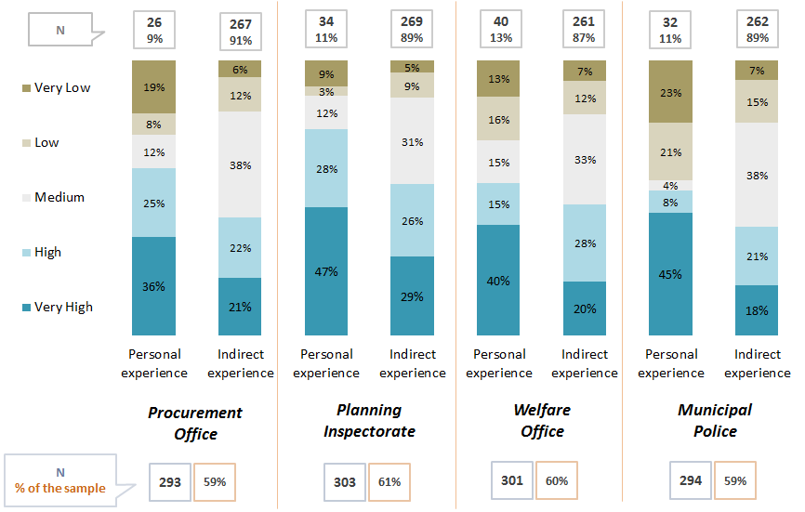
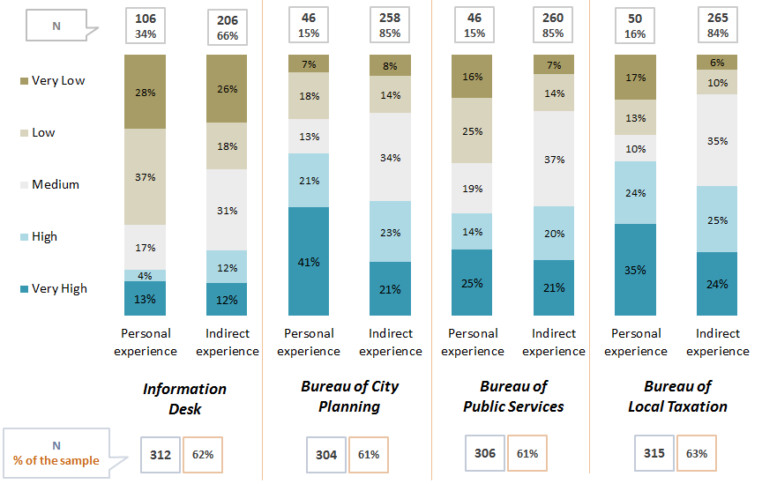 |  | 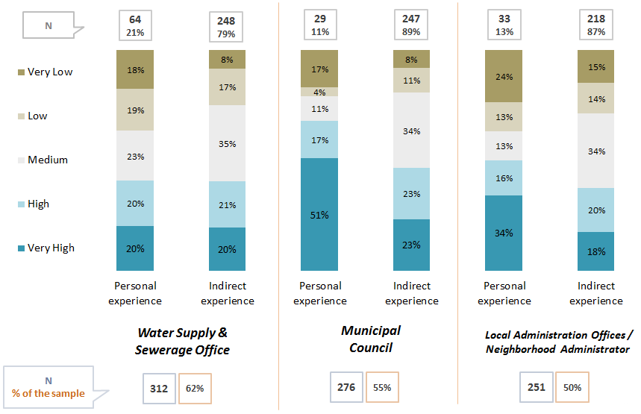
7.5 Perception on Level and Nature of Corruption in Sectors or Institutions of the Municipality of Fier  Whether coming from personal experience, or just something heard from friends, family etc. (indirectly) up to 74% of Fieri citizens believe that there is in fact corruption on at least one or more sectors/institutions of the Local Government and bribes are often necessary to get a service or solve an issue (Fig. 19).  Fig. 19 Perception on Level and Nature of Corruption in Sectors/ Institutions  of the Municipality of Fier  Again according to direct or indirect experience, Fieri respondents were asked about the nature of the bribery, whether it was just money that was demanded or other forms like personal favours or various gifts.  Up to 82% of respondents claim that Money is the main form of bribing demanded or implied to get a service or solve an issue.  Personal favours (24%) and various Presents (20%) are also seen as other possible means of bribing by the respondets, but on a much lower scale compared to Money.  Much alike, when respondents are re-asked about which in their |  | 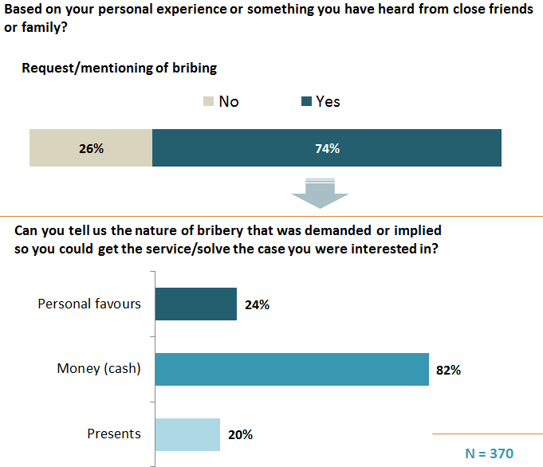  Multiple response
opinion is the most common form of bribery, over 91% declare that indeed Money is the most common form of bribery, while only about 7% claim that Personal Favours are in fact more common that other forms of bribery.

7.6 Perception on Corruption in Everyday Scenarios
Respondents were also presented with different corruption scenarios and asked whether the persons involved are corrupted and should be punished or are in any way justified while engaging in the corruption related activities that were presented. Interestingly enough, there is a difference in judging the “Demand” side of a corruption related instance compared to the “Supply“ side (Fig. 20).
Respondents are more prompt in punishing the corrupted party in the classic clear cut scenarios of corruption (like the municipality employee accepting different amounts of bribes, or the politician misusing his influence), while they seem to justify or even not punish at all scenarios like the one involving the person that hired the employee (after the politician interfered) or the citizen that bribes so he doesn’t have to wait in line etc.
It is quite interesting that when analyzing Fieri citizen ’s perception on corruption after being presented with some every day scenarios, while breaking main sample down by age, younger age groups show high levels of tolerance towards the phenomenon of corruption and bribing more specifically, especially for the supplying party (Fig. 20b).  As seen in the graph the level of tolerance (at least at one case) towards the supplying party of the bribe, reaches up to 79% for the 18-34 year old age group, while standing lower at 65% for the older (55+ y.o.) age group. Much alike (although this time with higher attitude towards punishing corruption), while analyzing the demanding party, over half (52%) of younger respondents would still tolerate the corruptive act, while only 36% of older group (55+ y.o.) state alike. | 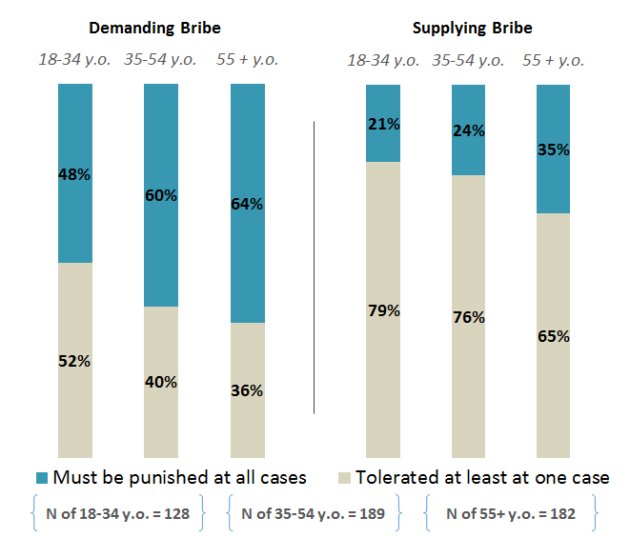  Fig. 20b Perception on Corruption in Everyday Scenarios (*Breakdown by Age)

OPINIONS ON LOCAL ECONOMY IN THE CITY OF FIER  8.1 Information on Taxes and Local Fees  Fig. 21 Information on Taxes and Other Local Fees  Up to 76% of Fieri citizens are aware of their obligations regarding taxes and other local fees (Fig. 21).  It is also worth mentioning that when Fieri sample is broken down by age we notice that younger ages (18-34 years old) are less informed of their obligations regarding taxes and other local fees (only 2 in 3 claim awareness on this matter) compared to older age groups (35-54 y.o. and 55+ both informed at the level of 80% on this matter). | If yes, where did you acquire this information?
The Municipal Office seems to be the most popular source Fieri citizens use (28%) to acquire information on taxes and other local fees.  Public Institutions follow with 24% of respondents using them on this regard.  Fieri citizens also seem to inquire about this kind of information at friends that may already be aware of various taxes or other local fees.  It is clear that the respondents will either go directly to the source (generaly the Information Desk of the Municipal Office) and inquire on the respective information, or ask a friend or acquaintance about it.  It is quite interesting that only 3% of Fieri respondents claim to have used the Municipality’s Web Page while searching for information on taxes and local fees. | Multiple response  N = 379

8.2 Economic Growth and Standard of Living
Fig. 22 Economic Growth and Standard of Living
Fieri respondents seem pesimistic while sharing their opinions over the economic growth in the city of Fier. Half of them (50%) claim that the Economy is Declining, while another 37% although not necessarily thinking that the economy is declining, are not noticing any changes in this matter either, compared to previous years.
What is your opinion over the economic growth of your city?
Only about 11% claim that the economy in the city of Fier is actually growing.
Compared to last 12 months your standard of living has:
Economic growth situation in the city of Fier is also reflected in Fieri citizens standard of living, when asked if they had noticed any changes on that matter, compared to last 12 months.
Over half of respondents (53%) claim that their standard of living has not changed compared to last 12 months, while up to 35% state that it has actually worsened.
Once more only 10% claim that their standard of living has improved compared to last 12 months.

Very promising and promising
Fig. 23 Potential Economic Sectors that are Strong and Promising Engines of Economic Growth

8.3 Potential Economic Sectors
Fieri citizens seem to agree that the Development of Aggricultural Products / Agro-processing along with the Heavy Industry (taking mostly in cosideration the oil reserves of Fieri and the potential development and growth of the petroleum industry there) are the two most important sectors that can actually lead to future economic growth in the city of Fier (Fig. 23).
Light Industry (products of daily consume, manufacturing, etc.) also shows promise as a potential engine of future economic growth according to at least 65% of Fieri citizens, boosting local economy while presenting job opportunities for many citizens.
8.4 Involvement of Local Government is Stimulating and Managing Economic Growth
Fieri citizens seem pesimistic when stating their opinion in regards to the Local Government’s involvement in stimulating and managing economic growth (Fig.24).
Over two thirds state that the Local Government isn’t involved in stimulating and managing economic growth (30% Not at all Involved & 39% Little Involved) in the city of Fier.
Only 22% claim that the Local Government is actually Involved in this regard.
How involved do you think the local government/municipality is in stimulating and managing economic growth?
Fig. 24 Involvement of Local Government in Stimulating and Managing Economic Growth
How involved do you think the local government/municipality will be in the next 5 years, in stimulating and managing economic growth?
Fieri respondents are asked again regarding the Local Government’s involvement in stimulating and managing economic growth, this time during the course of the next 5 years.
Citizens tend to be more optimistic in this regard, since over half of respondents now believe that the Local Government will be involved (21% Very Involved & 37% Involved) in stimulating and managing economic growth over the next 5 years, while only a third believes otherwise (23% Little Involved & 6% Not at all Involved.)

8.5 Civil Society
Fieri citizens show major lack of interest in getting involved with any various civil society structures, especially when it comes to religious groups, charity organisations or any NGO. Little activity is noticed with Political Parties, yet on very low levels.

MUNICIPALITY OF LUSHNJA
QUALITY OF LIFE IN THE CITY OF LUSHNJA
9.1 General Quality of Life
Lushnja citizens were asked to describe in general the quality of life in their city (Fig.25).
Respondents opinions are split on this matter, with half of them having a positive opinion regarding the quality of life in their city (46% Good & 3% Very Good), while the other half responding negatively (26% Bad & 24% Very Bad).
Interestingly enough, almost 1 in 4 Lushnja citizens believes the general quality of life in their city is “Very Bad”.
Fig. 26 Quality of Life in the City of Lushnja, over the last 3 years
Fig. 25 General Quality of Life in the city of Lushnja
Lushnja citizens were also asked whether they have noticed any changes (positive or negative) in regards to the quality of life in their city over the last 3 years (Fig. 26).

Up to 39% of respondents state that the quality of life has not changed at all over the last 3 years in the city of Lushnja, meanwhile the rest split again between the respondents claiming that the quality of life over the last 3 years has “Somewhat Improved” (23%) and the respondents claiming that it has “Somewhat Worsened” (17%) or “Greatly Worsened” (11%).
It is also worth mentioning that Lushnja youth (18-34 years old) show a higher level of satisfaction when asked about the general quality of life in the city of Lushnja (nowadays and over the last 3 years), compared to older citizens (55+ years old) that seem to be less positive on this matter.
9.2 Most serious problems that the city is facing  “Unemployment / Lack of Employment Opportunities” seems to be the first problem coming to mind according to over 50% of Lushnja citizens when asked which were the three most serious problems the city of Lushnja is being faced with nowadays. Another 9% of Lushnja respondents mention “Economic Problems” first, picturing a clear situation on the fact that almost two thirds of Lushnja citizens are primarily concerned with their financial situation (Fig. 27).  Unemployement also leads the board of the most serious problem the city of Lushnja is being faced with (whether mentioned 1st, 2nd or 3rd), mentioned by over 79% of Lushnja respondents.  “Weak Infrastructure” is also of high concern as it was also mentioned by over 74% of Lushnja respondents (and by 26% as the first problem the city is being faced with) almost at the same levels as “Unemployment / Lack of Employment Opportunities” portraying a clear picture on the two main problems the city is being faced with.  “Enviromental Pictures” are also present on almost a third (31%) of Lushnja citizen’s radar as another serious problem the city of Lushnja is being faced with. | FIRST MENTIONED ALL MENTIONED  Fig.27 Most serious problems that the city of Lushnja is facing nowadays

EVALUATION OF PUBLIC SERVICES IN THE CITY OF LUSHNJA  10.1 Responsibility on Problem Solving  Respondents were presented with different public services and asked whether the Central or Local Government was responsible in solving problems in those areas (Fig. 28).  There is still confusion among the respondents, especially for areas like the “Employment Office” where surprisingly up to 64% of respondents in Lushnja hold the Local Government responsible for this service and only 34% correctly state that it is the Central Government’s responsibility.  Other areas of confusion include “Pre-School Education” where up to 54% of respondents claim it falls to the responsibility of the Local Government, “Primary Health Care” or “Pre-University Education” (both at 29%), and “Electricity Supply” (23%).  Respondents seem to be more clear on basic public services like “Cleaning”, “Street Lightning”, “Maintenance of Roads”, “Sewerage” etc. that are in the responsibility of the Local Government. | Fig.28 Who is primarily responsible for solving problems in different Public Service Areas?

10.2 Satisfaction With Public Services
Fig.29 Satisfaction with Public Services

Respondents seem to be generally dissatisfied by the Public Services offered by the Municipality of Lushnja, since no positive evaluation surpassed the mid-scale of satisfaction level (Fig. 29).
Lushnja citizens are only somewhat satisfied with the “Maintenance of Pre-University Buildings” (45% Satisfied) and “Drinking Water Supply” (40% Satisfied).
On the other hand respondents are not satisfied with the “Maintenance of City Roads” (with 49% Unsatisfied and 24% Very Unsatisfied), “Sewage Service” (44% Unsatisfied and 24% Very Unsatisfied) and “Cleaning Service” (43% Unsatisfied and 22% Very Unsatisfied).
Those three areas should be the main focus for the Municipality to intervene.
Fig.30 Public Service level of improvement over the last 12 months
10.3 Public Services Level of Imrovement
Respondents were asked whether the Public Services that they earlier evaluated have had any improvements or not compared to last 12 months (Fig. 30).
Only about 1 in 3 respondents thinks that Lushnja Public Services have improved (27% Somewhat & 2% Greatly) over the last 12 months.
Meanwhile over half of respondents (51%) state that the Public Services have not changed at all during this time.

Fig.31 Public Service Priorities for the city to concentrate its resources
Most important
10.4 Public Service Priorities for the City to Concentrate its Resources

Respondents were specifically asked about the priorities where Lushnja Municipality should focus, given the lack of funds to support all areas of public service (Fig. 31).
“Condition of City Roads” appears to be of the Highest Priority according to 73% of respondents, closely followed by “Cleanliness of City” (72%), “Daily Water Supply” (69%), “Drainage Systems” (65%) and “Solid Waste Collection Disposal” (62%).
The respondents were also asked to name the one issue that needed the utmost immediate attention. In this case “Daily Water Supply” seems to be the Top Problematic Area according to 33% of respondents.

PERFORMANCE AND TRANSPARENCY OF PUBLIC ADMINISTRATION IN THE CITY OF LUSHNJE  11.1 Transparency of Central and Local Government  Lushnja respondents think that Local Government is in general not transparent. On a scale from 0-100, where 0= Not transparent at all and 100= Fully transparent, they have evaluated their Local Government with 27 points, way below the mid scale.  Opinion on transparency is higher when asked about the Central Government (34 points), but still below the mid scale.  While breaking down the Lushnja sample according to age, we notice that although scores are still below mid scale, younger age group (18-34 y.o.) has a more positive view towards the transparency of both Local and Central Governments, compared to other older groups (35-54 y.o. and 55+ y.o.) that seem less trusting on this matter. | Completely  transparent  Not at all transparent  Fig.32 Transparency of Local and Central Government
11.2 Information on the services and activities of the Local Government  Lushnja respondents do not feel well informed on the services and activities provided by the Local Government. When asked on how well the Municipality keeps them informed, only about 1 in 3 respondents have said “Well” (31%) or “Very Well” (5%).  The other 2 in 3 are not satisfied with how well the Municipality keeps them informed (34% Bad and 26% Very Bad) about the different activities and services of the Local Government. | Fig.33 How well does the Municipality keeps people informed of services and activities provided  Matters/Activities of the Municipality

11.3 Evaluation of Administration Operations of the Local Government
Lushnja respondents were asked to evaluate different items related to the administration operations of the Local Government (Fig.34).
Respondents tend to give a more positive evaluation towards service oriented instances like the “Behavior of Municipal Employees” or “Clear and Exact Rules and Procedures in Writing” and “Convenient Working Hours”.
Meanwhile respondents seem less likely to give a positive evaluation on performance oriented instances like “Creates a Feeling of Trust and Confidence” or “Easy to Contact the Right Person” and “Ability to Solve Problems/Give Answers”.
Fig. 34 Evaluation of Administration Operations
Fig. 35 Main Sources of Information Used to get Informed on City Matters/ Activities of the Municipality
11.4 Main Sources of Information Used to get Informed on City Matters/Activities of the Municipality
Local television stations are the main source of information about local news and municipal activities (mentioned by 67% of respondents). National television follows with 29% of respondents mentioning it (Fig. 35).
The Municipal Website is mentioned by only 8% of the respondents as a main source of information. Even more so, Social Networks (while widely used) are also not considered as a main source of information for local news (only 2% mention them as such).
It’s also worth noting that up to 27% respondents state that they “Are not Interested in these kind of News”.

11.5 Main 3 Mediums of Information  Local TV  TV4+ is mentioned by over 78% of respondents as the first Local TV channel they use to get information on city matters and different activities of the Municipality.  TV4+ is also mentioned as one of the three main mediums of information by almost all the respondents (98%), while MTV and TV7 are only mentioned by 23%. | Fig. 36 Main 3 Mediums of Information – Local TV  All Mentioned  First Mentioned
National TV  TOP CHANNEL is mentioned by up to 63% of respondents as the first National TV channel they use to get information on city matters and different activities of the Municipality.  TOP CHANNEL is also mentioned as one of the three main mediums of information by over 84% of respondents, followed by TV KLAN (59%), NEWS 24 (39%) and TVSH (32%). | All Mentioned  First Mentioned  Fig. 37 Main 3 Mediums of Information – National TV

Fig. 38 Accessibility and Availability of Information by the Local Government
Very Easy
Very Difficult
N = 428 | 86% of the sample
N = 449 | 90% of the sample
N = 440 | 88% of the sample
N = 435 | 87% of the sample
N = 428 | 86% of the sample
N = 429 | 86% of the sample
N = 420 | 84% of the sample
N = 400 | 80% of the sample
11.6 Accesibility and Availability of Information by the Local Government
Respondents were presented with different elements related to the Local Government’s work and asked to rate the availability and accessibility to this information (how easy would it be to find information for each respective element) on a scale of 0=Very Difficult through 100=Very Easy (Fig. 38).
Respondents generally think that it is rather difficult to find Information related to the Central Governments work, as most elements did not even reach the mid scale of difficulty. As seen in the graph, information on “Tender Bids/Procurements” (20 points), “Drafting and Execution of Budget” (22 points) score at very low levels, followed by information on “Licenses and Authorization” (26 points), “Urban Planning Studies compiled by the Municipality” along with information on “Actual or future projects” (both 30 points) are among the hardest of information to find.
On the other hand, according to respondents there is a higher availability and accessibility on information related to “Athletic/ Cultural Events” (47 points) or “Services offered by the Local Government” (37 points), but still bellow average.

PERCEPTIONS AND EXPERIENCES WITH CORRUPTION IN THE CITY OF LUSHNJA
12.1 Citizen Contacts with Municipal Structures
In overall, citizens of Lushnja show high interaction with Municipal structures. About half of the sample (51%) declared to have contacted, during the past 12 months, at least once with municipal structures (Fig. 39).
“Water Supply & Sewerage Office” along with the “Welfare Office” are the most contacted sectors (after the Information Desk) by Lushnja citizens. “Bureau of Local Taxation” also shows considerable citizen interaction, while the “Procurement Office” along with the “Municipal Council” structures are less likely to be contacted by Lushnja’s citizens.
Citizens only had to contact once or twice the bureaus of “Public Services” and “City Planning” for their issues, while the “Water Supply & Sewerage”, “Welfare Office” or “Bureau of Public Services” had to be contacted multiple times by Lushnja citizens.
How many Times?
Fig. 39 Have you contacted the following institutions during the past 12 months?

12.2 Overall Satisfaction with Services Received  Fig. 40 Overall Satisfaction with services received  Highest level of citizen satisfaction is registered at the “Bureau of Local Taxation” (a sector of high citizen interaction) with over 83% of respondents being at some level satisfied by the received service (Fig. 40).  Lushnja citizens also seem satified with the services received by the “Information Desk” (over 70% of respondents satisfied at some level), the “Local Administration Offices” and “Bureau of Public Services”.  Low level of satisfaction for services offered was registered at the “Bureau of City Planning” and “Municipal Police” where over half of citizens interacting declare to be “Unsatified” by services received.  Fig. 41 Direct or Indirect Demand of Bribing | N
12.3 Demand of Bribe  “Water Supply & Sewage Office” (a generaly rather problematic sector according to Lushnja citizens) along with the “Welfare Office” are among the most mentioned sectors, implicated with corruption and demand of bribes to get the service/solve problem.  In both sectors (sectors with high citizen interaction), over 1 in 5 citizens interacting with these offices claim that bribing was implied or directly requested (Fig. 41).  Regardless of intensity of interaction, other problematic sectors where bribing was implied or directly requested include the “Municipal Police”, “Construction Inspectorate” and “Bureaus of Public Services or Local Taxation.” | N

12.4 Perception on Level of Corruption in Sectors/Institutions of the Municipality of Lushnja  Lushnja respondents that contacted different sectors/institutions of the Municipality over the last 12 months were asked to evaluate the level of corruption in these institutions along with whether they based their evaluation according to a personal or indirect experience with these institutions (Fig. 42).  Fig. 42 Perception on Level of Corruption in Sectors/Institutions of the Municipality of Fier  Once more if we compare the opinion of those who have had Personal experiences with municipal structures and those who base their opinion on Indirect experiences, in most of the institutions evaluated, the perception on corruption level, is higher among those that have had personal experience than among those with indirect experience. It means that there is an issue with corruption, with which the municipality of Lushnja has to deal with, and it is not on a perception level only. | 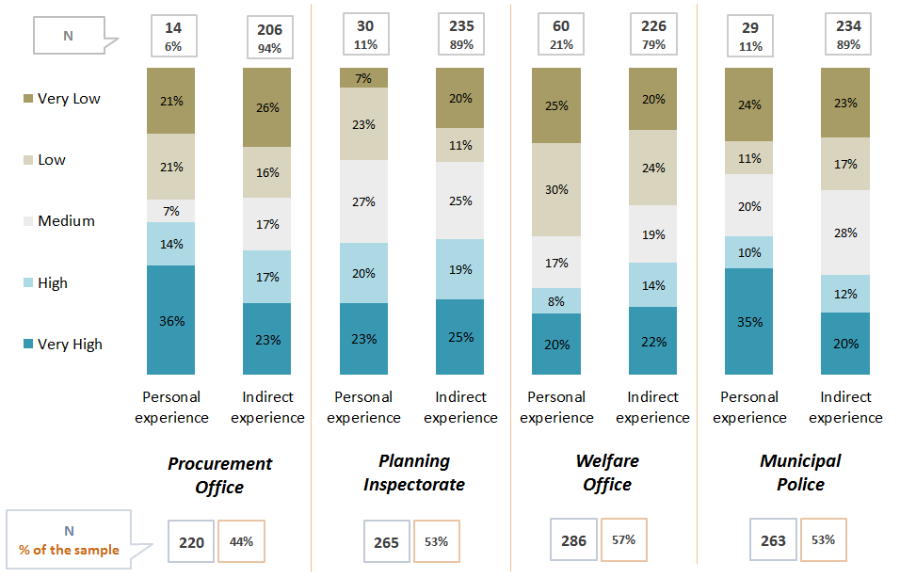
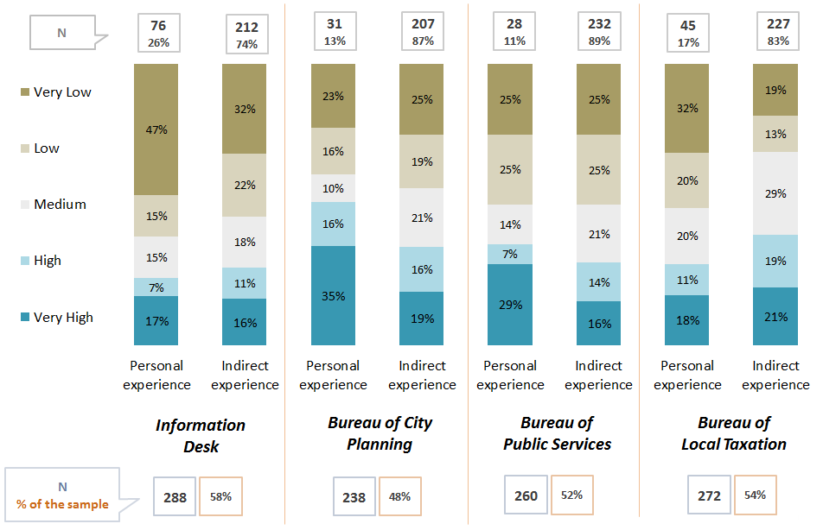 | 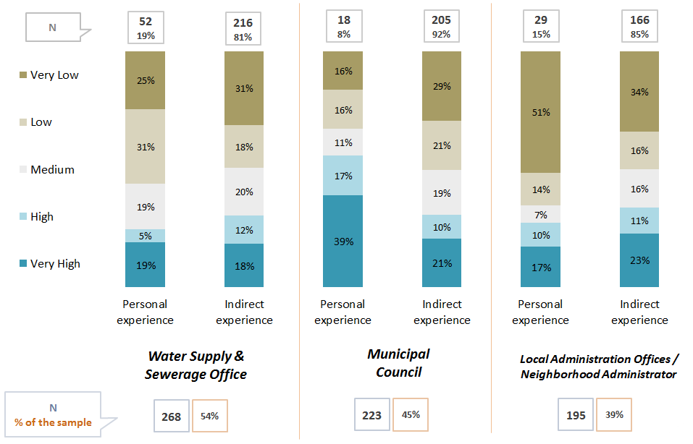

12.5 Perception on Level and Nature of Corruption in Sectors or Institutions of the Municipality of Lushnja  Whether coming from personal experience, or just something heard from friends, family etc. (indirectly) up to 69% of Lushnja citizens believe that there is in fact corruption on at least one or more sectors/institutions of the Local Government and bribes are often necessary to get a service or solve an issue (Fig. 43).  Fig. 43 Perception on Level and Nature of Corruption in Sectors/ Institutions  of the Municipality of Fier  Again according to direct or indirect experience, Lushnja respondents were asked about the nature of the bribery, whether it was just money that was demanded or other forms like personal favours or various gifts also.  Up to 90% of respondents claim that Money is the main form of bribing demanded or implied to get a service or solve an issue.  Presents (17%) and Personal favours (9%) are also seen as other possible means of bribing by the respondents, but on a much lower scale compared to Money. | 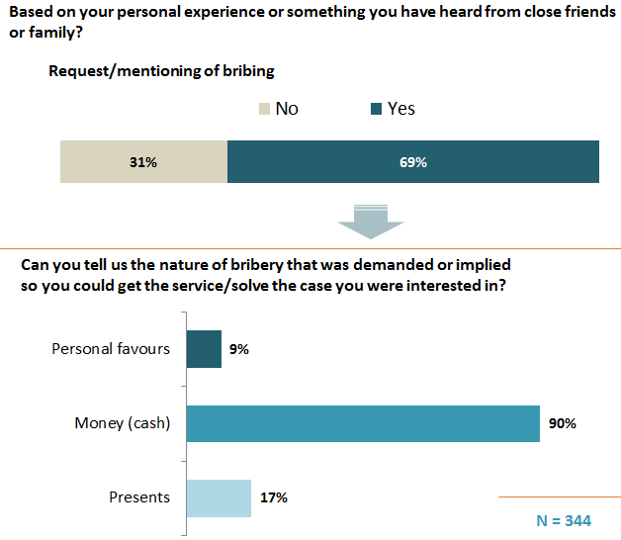
Much alike, when respondents are re-asked about which in their
opinion is the most common form of bribery, up 98% declare that indeed Money is the most common form of bribery, while only about 1% claim that Personal Favours are in fact more common that other forms of bribery.
What nature of bribery is the most common in your opinion?

Fig. 44 Perception on Corruption in Everyday Scenarios
12.6 Perception on Corruption in Everyday Scenarios
Respondents were also presented with different corruption scenarios and asked whether the persons involved were corrupted and should be punished or were in any way justified while engaging in the corruption related activities that were presented. Interestingly enough, there is a difference in judging the “Demand” side of a corrupt transaction compared to the “Supply“ side. Respondents are more tolerant when judging the “Supply” side and a significantly tolerant attitude is noticeable with respondents not necessarily mentioning “Punishment” in relation to at least one corrupt transaction presented.
Respondents are more prompt in punishing the corrupted party in the classic clear cut scenarios of corruption (like the municipality employee accepting different amounts of bribes, or the politician misusing his influence) while judging these behaviours as “Corrupted and in need of Punishment”, while they seem to justify scenarios like the one involving the person that hired the employee (after the politician interfered) or the citizen that bribes so he doesn’t have to wait in line etc.
It is also worth mentioning that when breaking down Lushnja sample by age, the older age group (55+ y.o.) seems more eager in punishing the corrupted party (in both demanding and supplying cases of bribing) compared to the younger groups (of 18-34 y.o. and 35-54 y.o.) that are generally more promt towards tolerating bribing, at least at one case of it.

OPINIONS ON LOCAL ECONOMY IN THE CITY OF LUSHNJA
13.1 Information on Taxes and Local Fees
About two out of three (67%) citizens of Lushnja declare to be aware of their obligations regarding taxes and other local fees, while a third of respondents (33%) declare that they are not aware of their obligations on this matter (Fig.45).
Fig. 45 Information on Taxes and Other Local Fees
Are you aware of your obligations regarding taxes and local fees?

Almost a third (30%) of Lushnja respondents state to have acquired this information directly at the Municipal Office.  Other sources of information on taxes and local fees include Media Ads (15% of respondents declare to have acquired this information through them) and Information Leaflets issued by the Municipality (another 15% of respondents declare to have acquired this information through them).  Interestingly enough, only 1% declare to have acquired information on taxes and local fees through the Internet or more specifically through the Web Page of the Municipality  If yes, where did you acquire this information? | N = 416

13.2 Economic Growth and Standard of Living
Fig. 46 Economic Growth and Standard of Living
What is your opinion over the economic growth of your city?
Lushnja respondents were asked to give their opinion over the economic growth of their city.
About 44% of respondents express their pessimism by stating that the economic growth of their city is declining, while about just as many (40%) think that the economy is not actually changing at all. Only 14% think that the economy is growing.

The results are near similar when respondents are asked about their own standard of living situation compared to last 12 months. Almost half (47%) of respondents think their standard of living has not changed compared to last 12 months, while 38% state this it has actually worsened.
Compared to last 12 months your standard of living has:

Fig. 47 Potential Economic Sectors that are Strong and Promising Engines of Economic Growth
Very promising and promising
13.3 Potential Economic Sectors
“Development of Agricultural Products/Agro-processing” is described as the strongest and most promising engine of economic growth by up to 82% of Lushnja citizens, way ahead of the other mentioned sectors. “Warehouses and Transport” also show potential according to 52% of respondents.
Heavy Industry is barely considered as a potential engine of economic growth, with up to 62% of respondents describing it as “Not at all Promising”.
Much alike, “Tourism” and “Light Industry” are both described as “Not Very/Not at all Promising” by over 60% of respondents.

13.4 Involvement of Local Government is Stimulating and Manging Economic Growth
Lushnja respondents were asked to give their opinion in regards to the level of involvement of the Local Government in Stimulating and Managing Economic Growth.
Up to 44% of respondents think that the Local Government is “Little Involved” in stimulating and managing economic growth while only 21% think that the Local Government is actually involved (18% Involved and 3% Very Involved).
How involved do you think the local government/municipality is in stimulating and managing economic growth?
Fig. 48 Involvement of Local Government in Stimulating and Managing Economic Growth
There is a slight tendency of optimism when asked again about the potential involvement of the Local Government in the next 5 years, where more than a third of respondents (35%) now think that the Local Government will be “Involved”, while only 11% think that it will “Not be involved at all” in stimulating and managing future economic growth.
How involved do you think the local government/municipality will be in the next 5 years, in stimulating and managing economic growth?

8.5 Civil Society
Citizens of Lushnja seem majorly uninterested towards engaging in any Civil Society structures. In the cases of NGOs, Charity Organisations and Religious Groups over 90% declare never to have been members of any of these structures, while some low activity is noticed at Political Parties, with 4% of respondents claiming to actually being members of and about 6% claiming that they used to be a member in the past.

